SPECIAL EMPHASIS PROGRAM AFTER ACTION REPORT
Submitted by: Marguaree Durden Pyoas
Special Emphasis Program Manager

Celebrating the Life and Legacy of Dr. Martin Luther King, Jr.
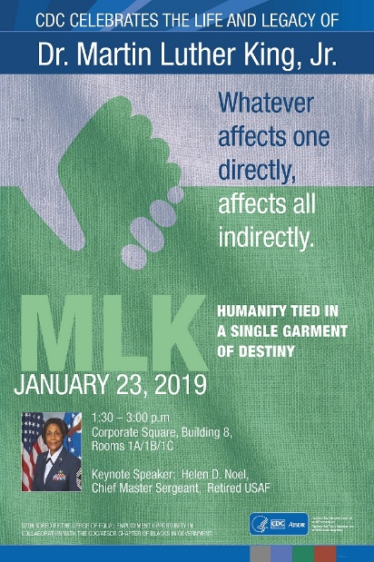

“King’s Vision: Humanity Tied in a Single Garment of Destiny”

Executive Summary
The 2019 CDC Celebration of the Life and Legacy of Dr. Martin Luther King, Jr. was held on January 23, 2019, at the Corporate Square Campus, in conference room 1A/B/C from 1:30 – 3:00 p.m.
The program was moderated by James C. Clausell, Sr., who is the 2nd Vice President of the CDC/ATSDR Chapter of Blacks in Government. Dr. Leandris Liburd followed with the welcome and opening remarks on behalf of Dr. Redfield. Cadacia Green, Disability Program Manager in the Office of Equal Employment Opportunity introduced the keynote speaker. The keynote speaker, Helen D. Noel, CMSGT (Ret.) USAF, had a very moving and powerful story. The story of how her personal life experiences with trauma and PTSD and how her perseverance of justice for her family emulate Dr. King’s dedication in the pursuit of justice and equality for all people. Dr. King wrote in a letter from his jail cell, “We are caught in an inescapable network of mutuality, tied in a single garment of destiny. Whatever affects one directly, affects all indirectly.” As the audience began to participate in the Q&A session, it was obvious that Ms. Noel had sparked an area that many don’t talk about whether it’s because of social stigma or simply not knowing how to address trauma and PTSD in their lives. There were many retired veterans in the audience who contributed to a very robust discussion.
Reggie Mebane, Director of the Office of Equal Employment Opportunity made special presentations to the keynote speaker and the CDC/ATSDR Chapter of Blacks in Government, followed by closing remarks by Kenneth Archer, Executive Vice President of the CDC/ATSDR Chapter of Blacks in Government.
Some of the comments from individuals on Skype were:
Walker, Lori-Ann (CDC/DDPHSIS/CGH/DGHT) 2:09 PM:
AWESOME! Thank you for sharing this powerful story

Bessler, Patricia (CDC/DDID/NCHHSTP/DHPIRS) 2:15 PM:
Thank you so much for sharing your story. Your strength and courage is truly inspiring!

Jones, Brenda J. (CDC/NIOSH/DART) 2:20 PM:
This program is truly an eye-opener. TRAUMA comes in many forms. Thank you so much for sharing your story. Amazing, awesome, inspiring--keep on pressing. This battle is not yours...

Legros, Jessie R. (CDC/DDPHSIS/CSTLTS/DPIFS) 2:23 PM:
What a powerful story! Please continue to share!

Buissereth, Sparkle (CDC/DDNID/NCCDPHP/DHDSP) (CTR) 2:23 PM:
Awesome!

Jones, Katrina (CDC/OCOO/OCIO) 2:25 PM:
Thank you for sharing!!! Powerful story

Thomas-Proctor, Melissa (CDC/DDID/NCHHSTP/DHPIRS) 2:34 PM:
As a military Air Force brat, a survivor of childhood PTSD, this was the best presentation ever!!! Thank you for your story. It truly helped me today. Go Air Force, M

Hendricks, Kay (CDC/DDPHSIS/CPR/DSAT) (CTR) 2:37 PM:
This is awesome, thanks CDC and all who are involved!

Wade, Danny (CDC/DDNID/NCIPC/DARPI) 2:43 PM:
Awesome job! Well done! Go Army!

The program was attended by 80 in the audience and 83 via Skype for a total of 163. Total budget expenditures for the event were $2,282.

